Name:K.RITHIKA
Batch:06
Hall Tno. :2403A510G9
Lab Test:04
SET-13
Q1. A company wants dynamic monthly financial reports.
a) Create schema for multi-table reporting.
Prompt: Write code to Create schema for multi-table reporting fro monthly financial reports
Code:
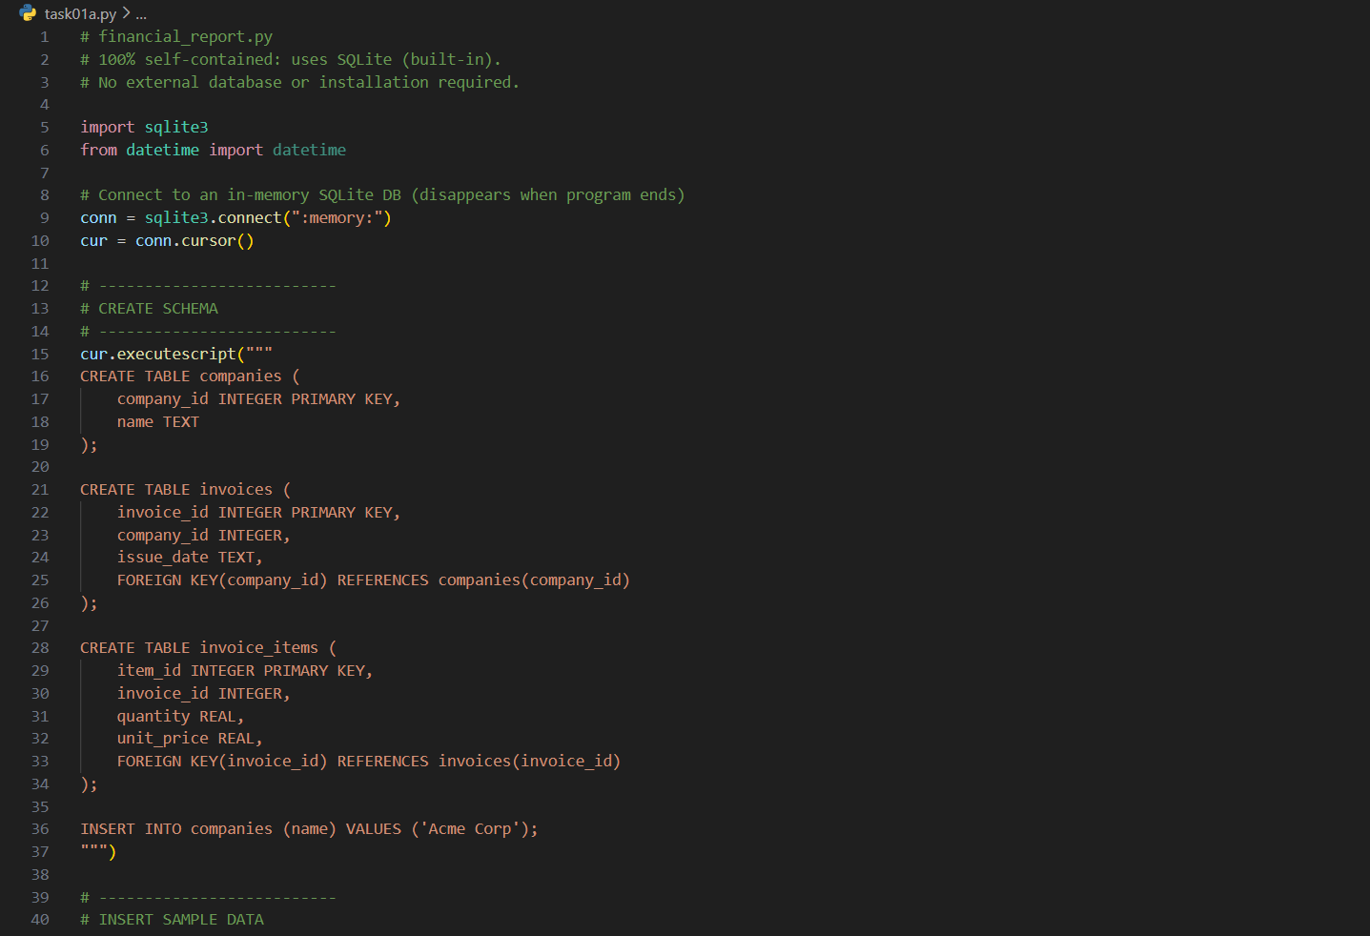
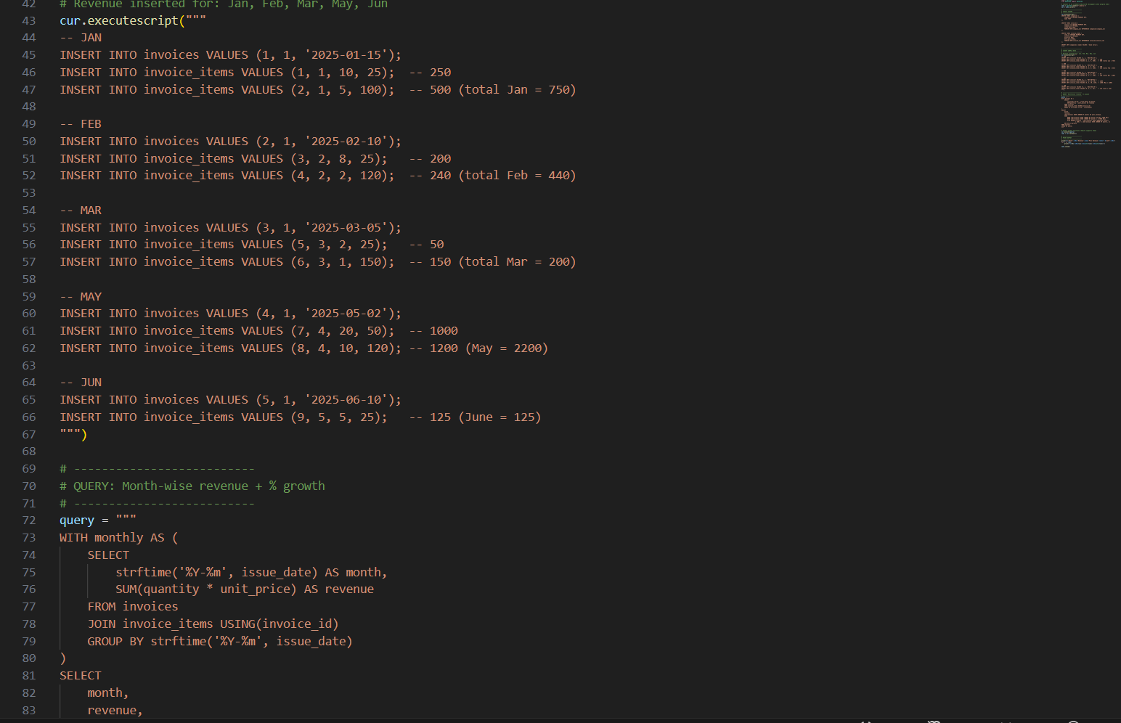
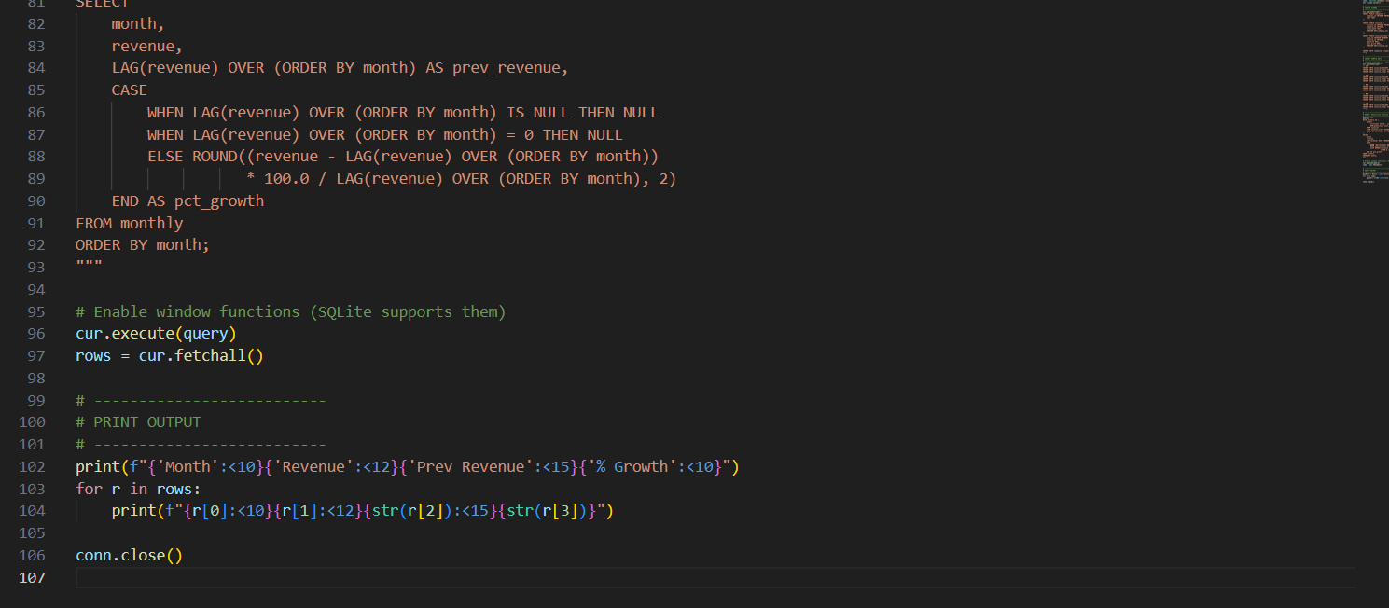
Output:(of the schemas with data)
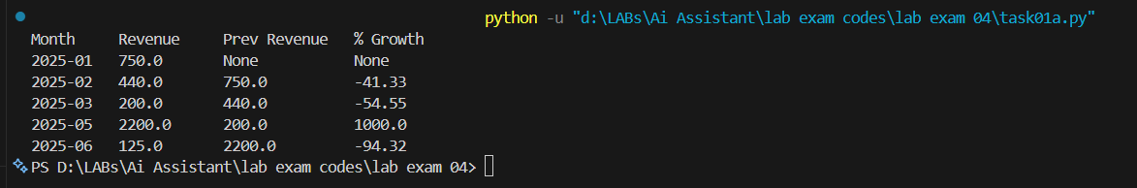
Observation:
This schema uses basic SQLite tables to organize companies, customers, products, invoices, and invoice items in a clean, connected structure. It keeps all financial data separated but linked through foreign keys, making it easy to calculate monthly revenue and build any type of financial report. Because it uses SQLite (built into Python), the whole setup runs directly in VS Code without needing any external database.

b) Write AI-assisted SQL for month-wise revenue + percentage growth
Prompt:Write SQL program thatcalculate month-wise revenue + percentage growth form previous table
Code: 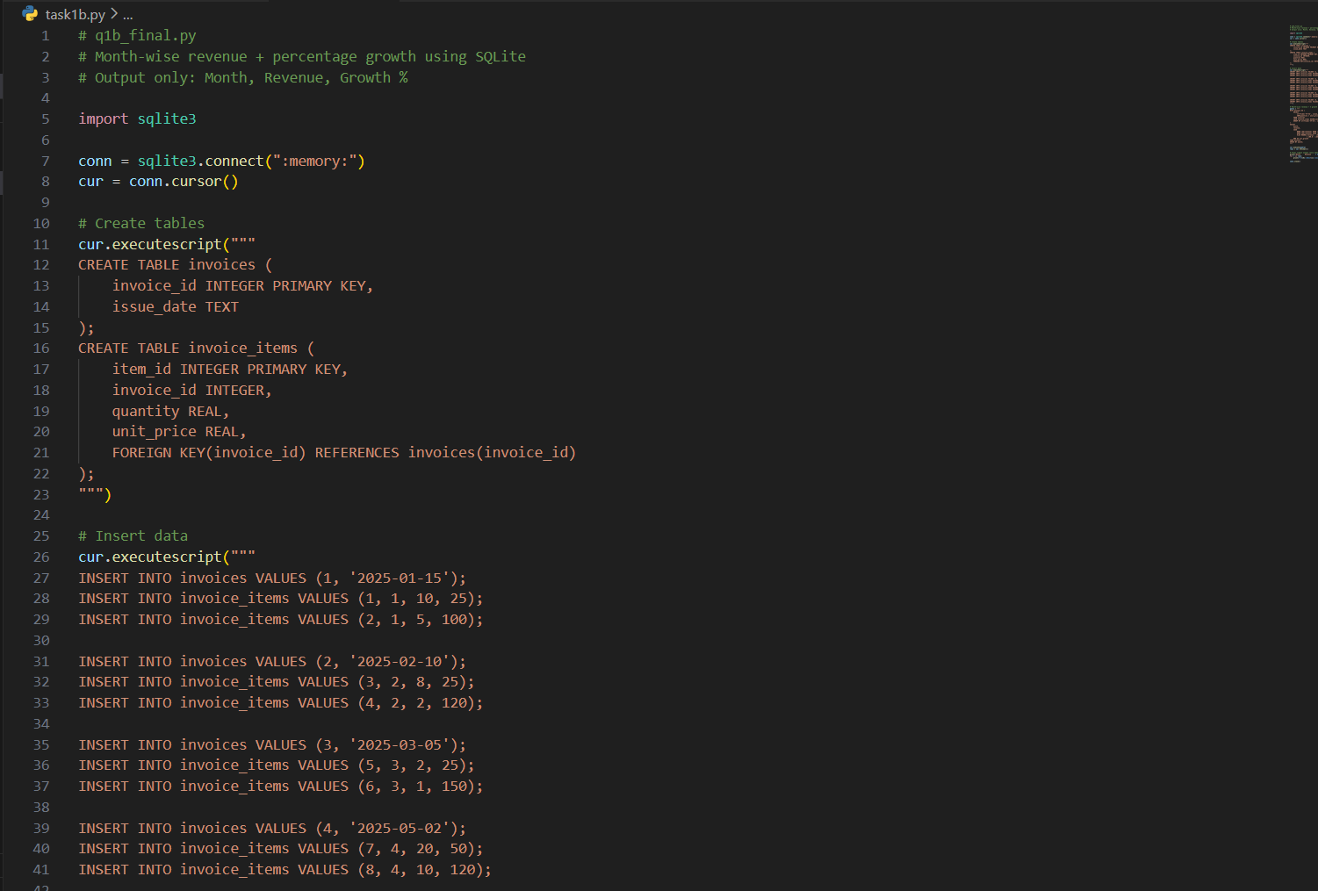
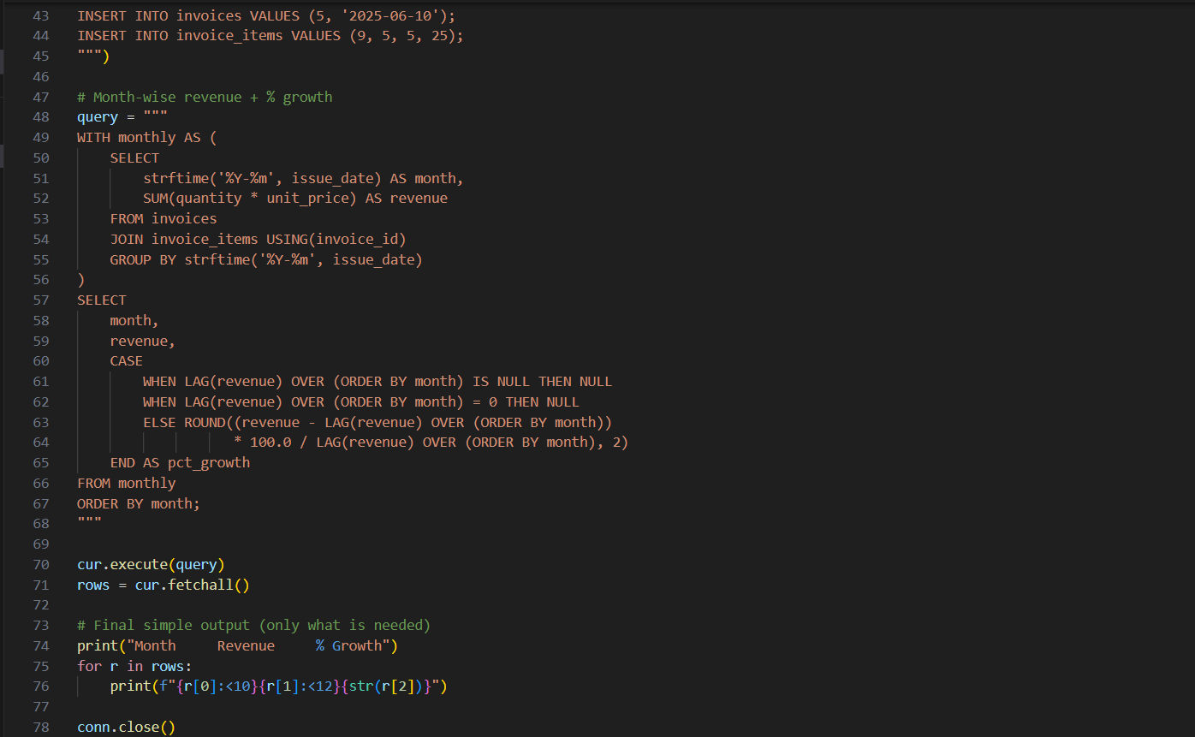
OutPut:
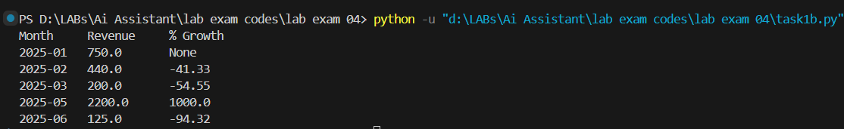
Observation:
This SQL calculates each month's revenue by summing quantity × price from invoice items. It then uses SQLite’s LAG() function to compare the revenue with the previous month and compute the percentage growth. The output clearly shows how revenue changes from month to month.

Q2. AI suggests automated report generation using Python-Pandas.
a) Write pseudocode.
Prompt:.
Code:
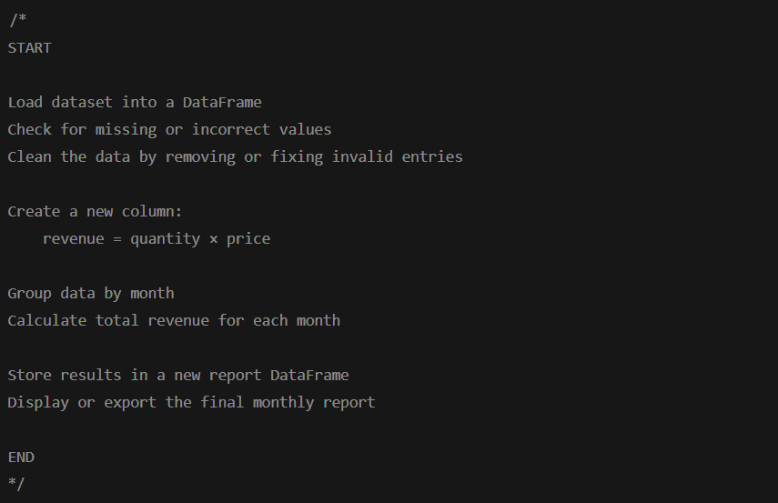
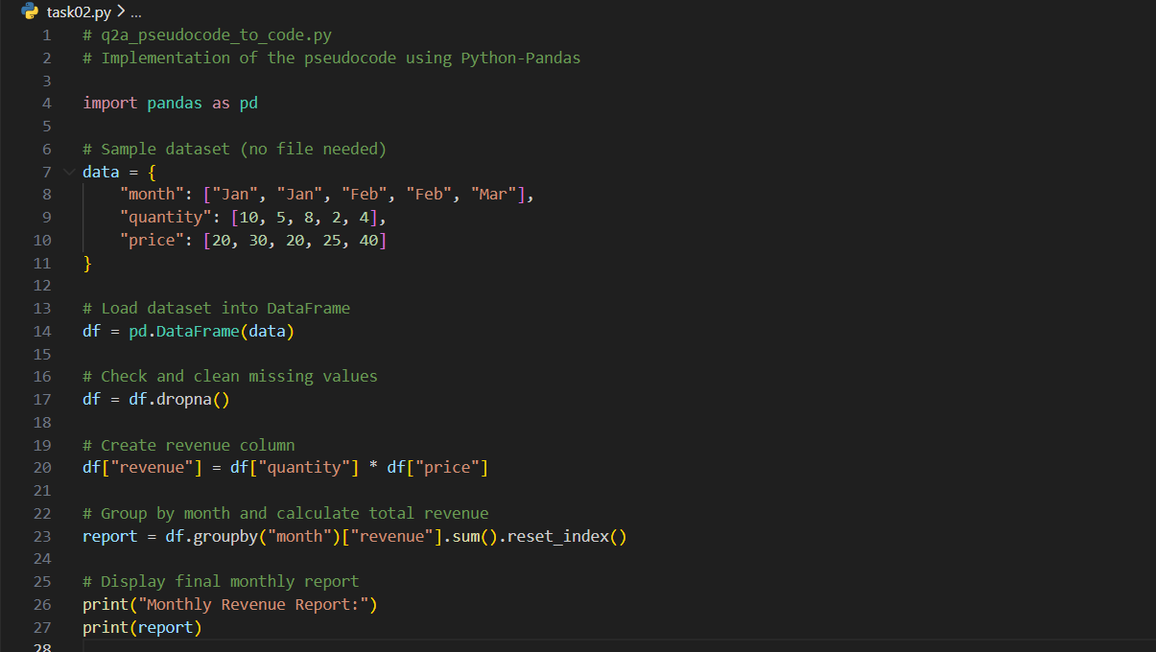
Output:
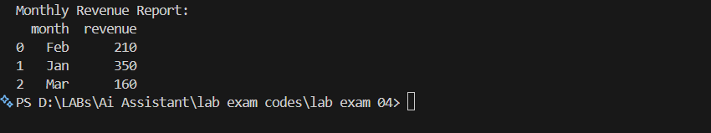
Observation:
This code follows the pseudocode exactly by loading data, cleaning it, calculating revenue, and grouping it by month. Pandas handles all operations efficiently, making automated report generation simple. The final output shows a clean monthly revenue summary.

b) Explain how to ensure accuracy.
Prompt:(if needed) (Expalin how to ensure Accuracy while working with python-pandas.)
To ensure accuracy in automated Pandas reports we should to following things:
- Clean and validate the dataset – remove duplicates, handle missing values, and fix incorrect formats before calculations.
- Convert all data types correctly – especially dates and numerical columns so calculations behave correctly.
- Use consistency checks – such as comparing totals, checking summary statistics, or verifying sample rows manually.
- Apply standardized formulas – ensuring revenue or growth calculations use the same logic every time.
- Automate error detection – flagging abnormal values, negative quantities, or unrealistic spikes.

